MANAV RACHNA UNIVERSITY

COMPUTER NETWORKS LAB FILE

FILE 5,6

**HARSH MITTAL**

**2K19CSUN01082**

**CSE5C**

**LAB-5**

**1.Using packet tracer connect the computers in LAN using Hub.**

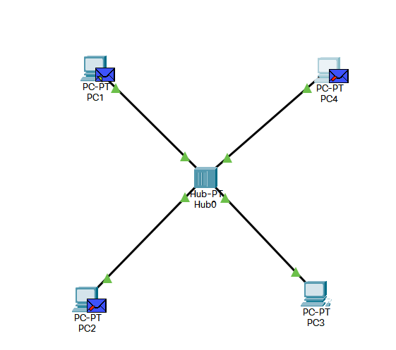

**2. Connecting two LANs using cisco packet tracer.**

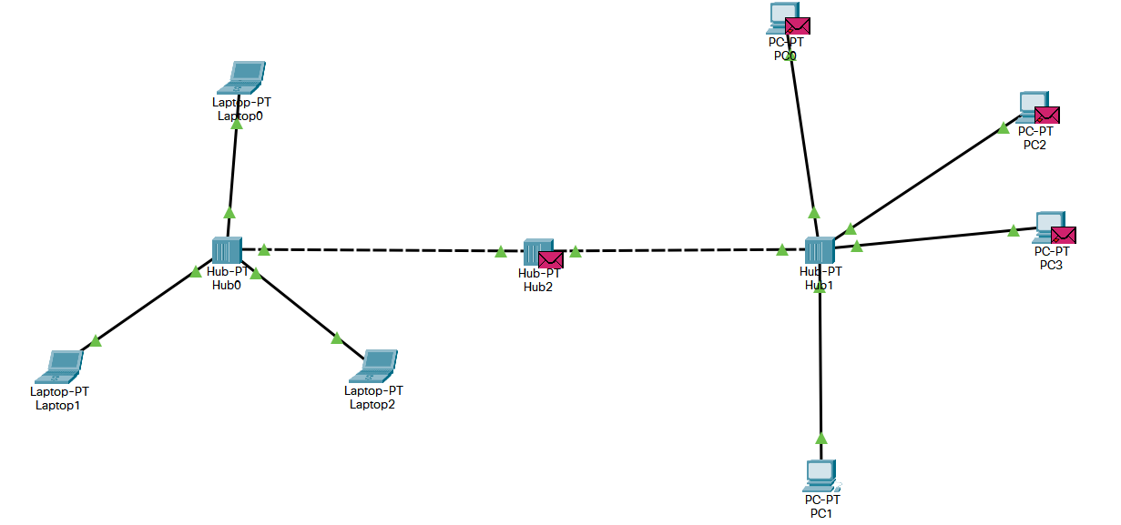

**3.Difference between the switch, hubs, and router.**

### Switch-

A switch is a multicast networking device that works under the Datalink layer of the OSI model and connects a bunch of computers or devices in a network. It’s mainly used to send a private message and it does not waste data.

A switch can easily identify which device is connected to which port by using a MAC address giving it the ability to deliver the message to a particular machine.

#### Advantages of using a Switch

* It’s secure since it delivers data to the specified node.
* It lowers the chances of frame collisions domains.
* It increases the bandwidth in a network.
* It increases the number of ports needed to connect the nodes available in a network.
* It operates under full-duplex.

#### Disadvantages of using Switches

* They are more expensive compared to hubs and other devices used in a network.
* To deal with multicast parcels, proper planning is required.
* Problems may arise when broadcasting traffic.

### Hub-

A Hub is a simple and cheap networking device that works under the physical layer of the OSI model and connects a bunch of computers in a Local Area Network(LAN). It is considered less intelligent because it does not filter data and does not know where the data is to be sent.

All information sent to a hub is automatically sent to all ports of the devices connected to it. This leads to a wastage of bandwidth.

#### Advantages of using hubs

* They have the ability to connect to the network using different physical media.
* They can be used to increase the network distance.
* Hubs are relatively cheap compared to switches and other devices in the network.

#### Disadvantages of using a hub

* It increases the chances of collision domains between packets when being transferred from one device to another.
* Hubs operate under half-duplex. Only one device can send or receive data at a time
* Hubs share data to all the devices in a network thus making the network insecure.
* Hubs waste lots of bandwidth when transmitting data.

### Router-

A Router is a networking device that operates under the network layer of the OSI model and is used to connect two or more networks. It is a device that establishes a common link between networks to enable data flow between them.

#### Advantages of Routers

* With the aid of dynamic routing algorithms, it can choose the best path in the internetwork.
* It creates collision domains to reduce network traffic.
* It provides connections between different network architectures.

#### Disadvantages of Routers

* They are expensive compared to hubs and switches.
* They need to analyze data. This makes them slower.
* They have low bandwidth because of their dynamic router communication.

Let’s look at their differences on the OSI model.

**LAB-6**

1. **Find mac address on the switch**

